Title
Midwives

Premiere
World Cinema Documentary Competition @ Sundance 2022

Runtime
91:26 mins

Production Companies
EYESTEELFILM, AMA FILM, Snow Films

Countries of Production
Myanmar, Canada, Germany

Logline
Two midwives, one Buddhist and one Muslim, defy strict ethnic divisions to work side by side in a makeshift clinic in western Myanmar, providing medical services to the Rohingya of Rakhine State. Over five years we witness their struggles, hopes and dreams amidst an environment of ever-increasing chaos and violence.

Synopsis
Hla and Nyo Nyo live in a country torn by conflict. Hla is a Buddhist and the owner of a makeshift medical clinic in western Myanmar, where the Rohingya (a Muslim minority community) are persecuted and denied basic rights. Nyo Nyo is a Muslim and an apprentice midwife who acts as an assistant and translator at the clinic. Her family has lived in the area for generations, yet they are still considered intruders. Encouraged and challenged by Hla, who risks her own safety daily by helping Muslim patients, Nyo Nyo is determined to become a steady health care provider for her community.

Snow Hnin Ei Hlaing’s remarkable feature debut was filmed over five turbulent years in a country that has long been exoticized and misunderstood. The filmmaker’s gentle, impartial gaze grants unique access to these courageous women who unite to bring forth life. Filled with love, empathy, and hope, Midwives offers a rare insight into the complex reality of Myanmar and its people.

- Ania Trzebiatowska

Bios
Director/Producer/Editor
Snow Hnin Ei Hlaing

Snow has worked as a freelance filmmaker in Myanmar since 2006, acting as director, producer, editor and sound recordist after attending film Schools in both Myanmar and Germany. Her short, BURMESE BUTTERFLY played festivals in over 20 countries, and PERIOD@PERIOD won for best short at the Wathan Film Festival. MIDWIVES is her feature documentary debut.

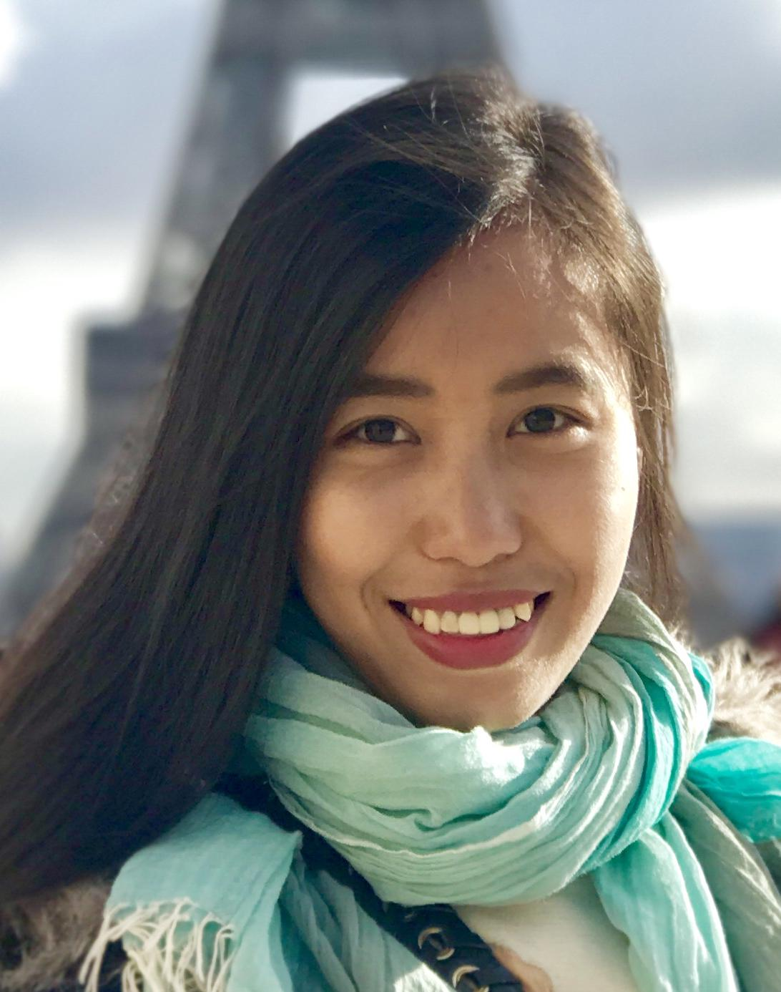

Producer
Ulla Lehmann

Producer Ulla Lehmann was born in Berlin and has lived in Germany and France. Together with film director Andrea Roggon, she founded AMA FILM. The company focuses on the development and production of creative documentaries and films of artistic and social relevance, e.g. MÜLHEIM TEXAS by Andrea Roggon (Max Ophüls Preis, Crossing Europe), THE INNER LIGHT by Stefan Sick (Berlinale, Shanghai IFF), WOOD AND WATER by Jonas Bak (Berlinale, New Directors/New Films N.Y.) and MIDWIVES by Snow Hnin Ei Hlaing (Sundance Film Festival). AMA FILM also acted as distributor and released THE INNER LIGHT to over 70 German cinemas.

Producer/Editor
Mila Aung-Thwin

Mila Aung-Thwin is co-founder of the Montreal documentary production company
EyeSteelFilm. He has produced more than 40 feature documentaries including Last Train Home (winner of 2 Emmy Awards); Up the Yangtze (Independent Spirit Award Nominee; Golden Horse Award winner); Rip: A Remix Manifesto (Webby Award Honoree; IDFA audience choice prize winner); and I Am the Blues (Canadian Screen Award winner). He is the executive producer and editor of Softie (Sundance World Cinema Documentary Special Jury Award winner for Editing). He directed, produced, and edited Let There Be Light (Big Sky Film Fest’s Artistic Vision award winner) about mankind’s epic quest for fusion energy. He has worked with broadcasters around the world, including National Geographic, BBC, ZDF/ARTE, NHK Japan, PBS, etc. He served for five years as President of RIDM, Montreal's international documentary festival and has served on the juries of the Sundance Film Festival, the International Emmy Awards, and the New Zealand Screen Awards. He frequently mentors and gives documentary storytelling seminars to upcoming filmmakers - recent workshops include Guangzhou, China; Ouagadougou, Burkina Faso; and Yangon, Myanmar.

Producer
Bob Moore

Bob Moore is Co-President and Creative Producer at EyeSteelFilm in Montreal where he has produced over 40 feature documentaries since 2008. Together with his talented partners and collaborators, he has been the recipient of over 100 international awards, including Emmys, Cinema Eyes, Golden Horses, Owls, Phoenixes, and a variety of other celebratory animal-themed prizes. He’s been the subject of a Producer’s Spotlight at the Cannes Marché du Film, is currently an advisor and mentor working with the Sundance Film Festival, IDFA, DMZ Docs South Korea, QUMRA, Tokyo Docs, Dhaka DocLab Bangladesh, Hot Docs, and RIDM.

Still 1 -
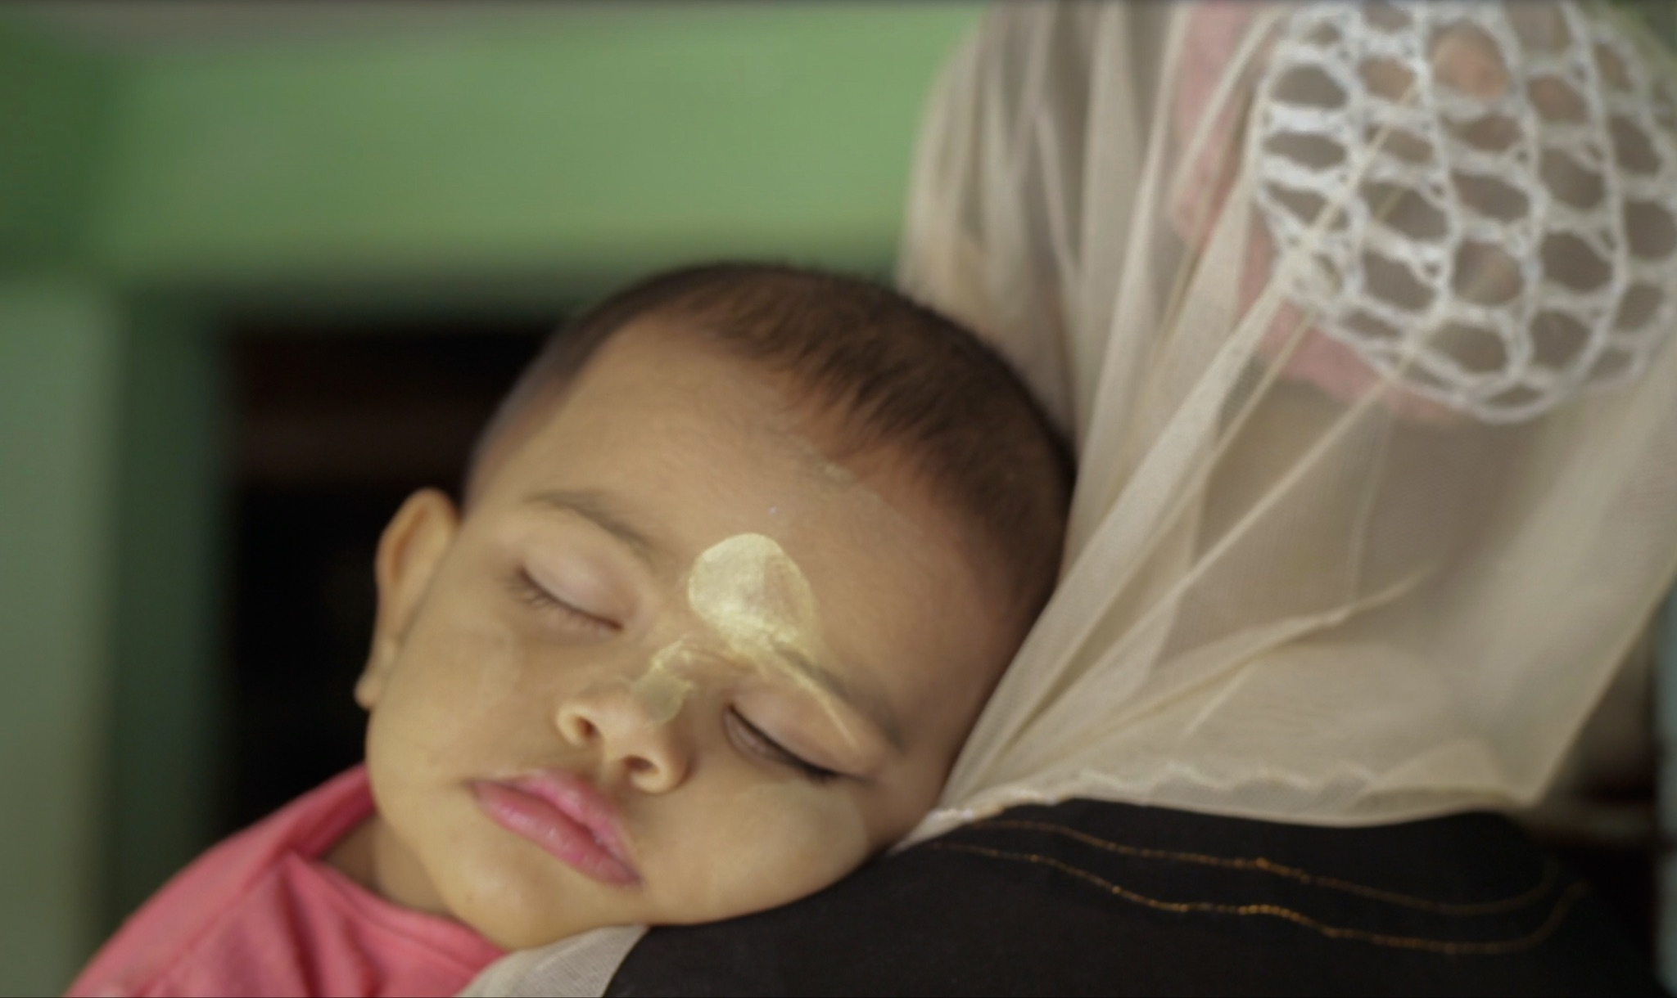

Still 2 -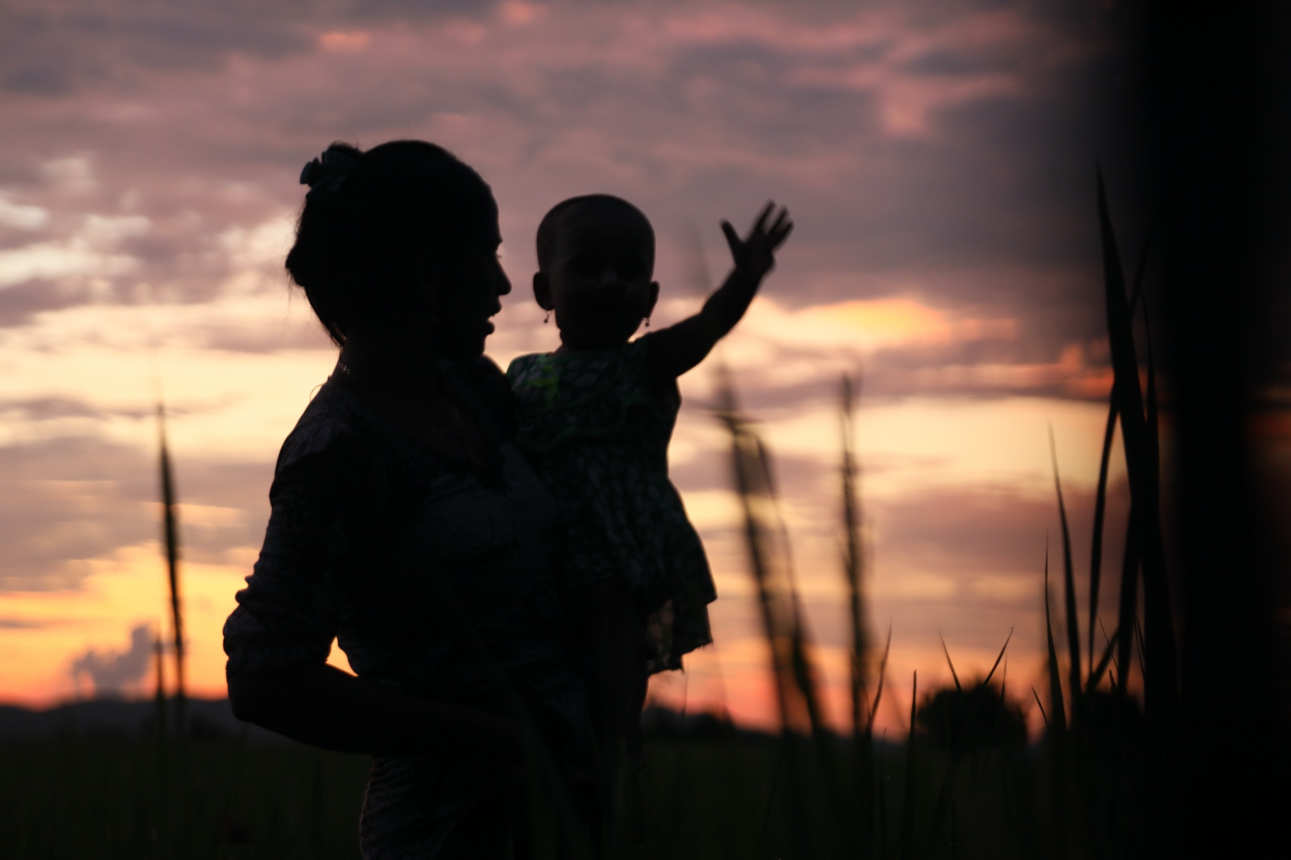

Director’s Statement

…

Poster
…

Social Media

Instagram: @midwives.film
Twitter: @eyesteelfilm
Hashtag: #midwivesfilm
Facebook:

Credits

Featuring
Hla
Nyo Nyo
Kyaw Kyaw
Kyaw Tin
BiBi
Producers
Bob Moore
Ulla Lehmann
Mila Aung-Thwin
Snow Hnin Ei Hlaing

Executive Producers
Ken Pelletier
Shizuka Asakawa

Executive Producers
Daniel Cross
Andrea Roggon

Executive Producers
Erika Dilday
Justine Nagan
Chris White

Executive Producer
Vijay Vaidyanathan

Executive Producer
Inmaat Productions

Cinematographer
Soe Kyaw Htin Tun

Editors
Mila Aung-Thwin
Ryan Mullins
Snow Hnin Ei Hlaing

Original Music
Olivier Alary
Johannes Malfatti

Line Producer
Valerie Shamash

Co-Producer
Katie McKay

A co-production of American Documentary | POV

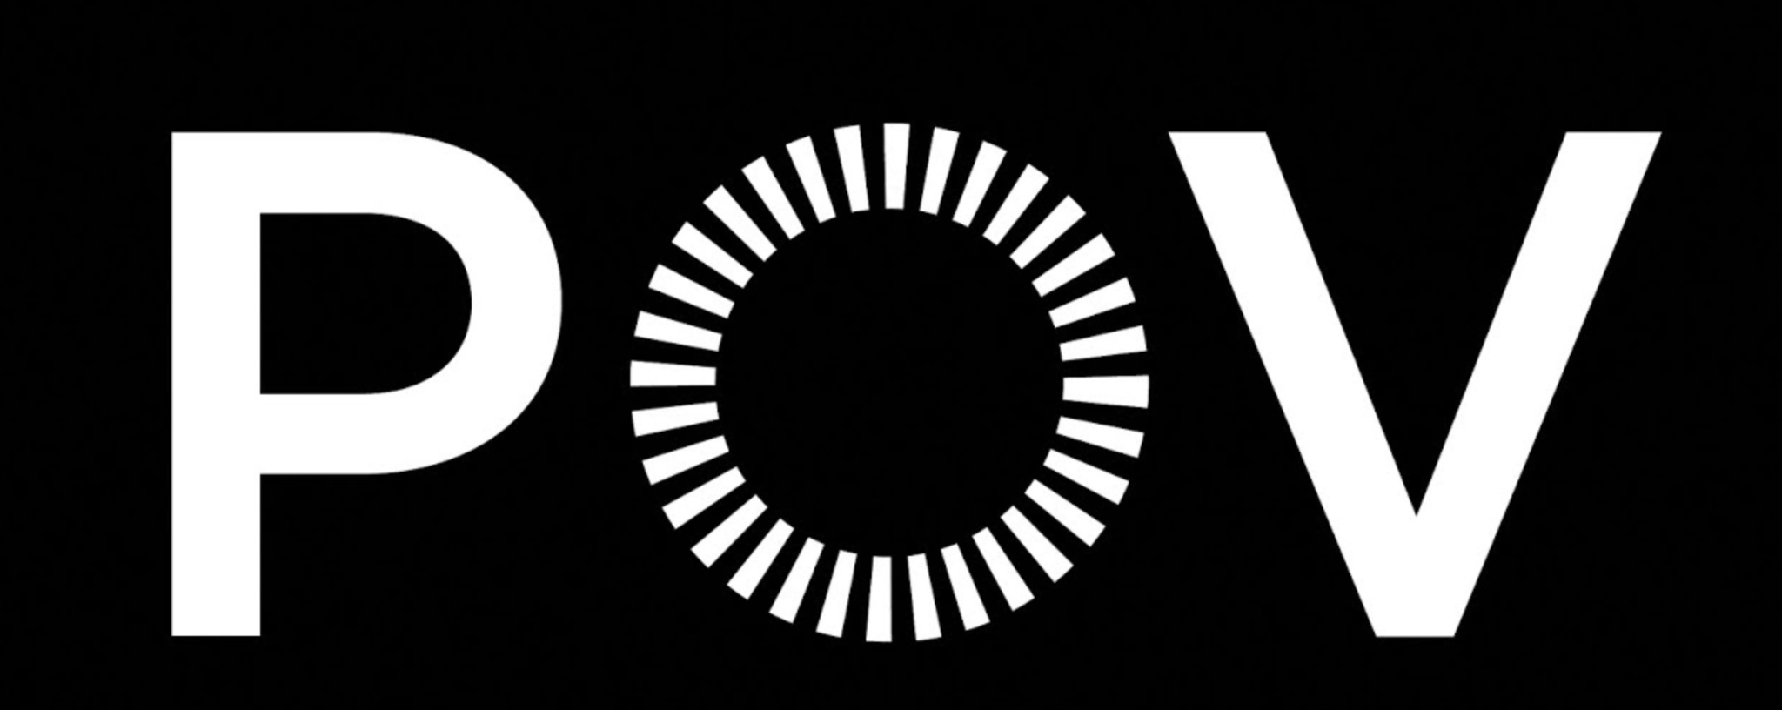

Supported by

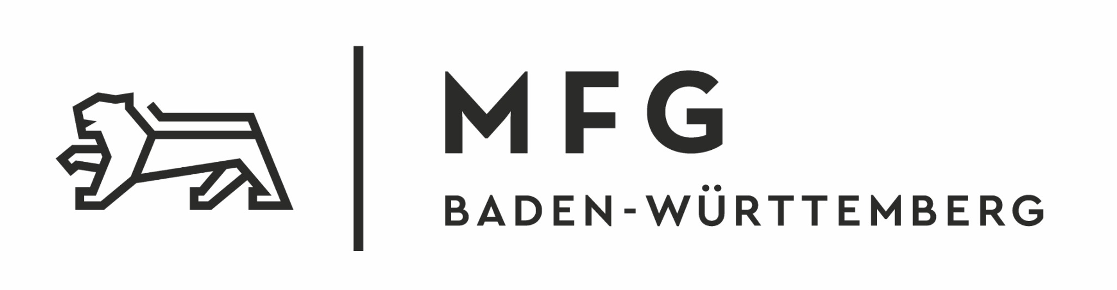

In Association with

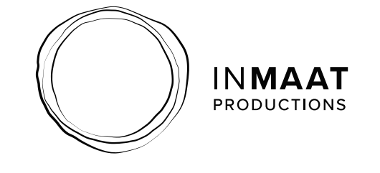
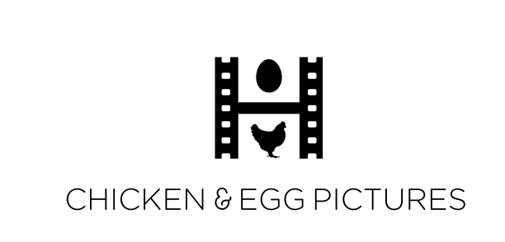

Additional cinematography
Thae Zar Chi Khaing
Snow Hnin Ei Hlaing

Location sound recording
Snow Hnin Ei Hlaing

Post Production Supervisor
Samantha Neboschizkij

Colorist
Hamed (Ed) Aleali

Assistant Editor
Samantha Neboschizkij

Additional Editing
Omar Majeed

Sound Studio
SONO2

Supervising Sound Editor
Andreas Mühlschlegel

Sound Design / Dialogue Editor
Andreas Mühlschlegel

Re-recording Mixer
Marc Fragstein

Foley Artist
Luis Schöffend

Foley Recordist
Marc Fragstein

Foley Editor
Constantin Kiefer

Myanmar Archival Sound
Ivan Horák

Digital Lab
BEWEGTE BILDER

Lab Supervisor
Carsten Schuffert

Mastering & Playouts
Mareike Eggebrecht
Harald Schäfer
Lea Winter

Title Design
Roland Matusek

Transcription
Ja Roi Aung Lashi
Mi Mi Kyaw Lwin
Kyaw Za
Aye Mon Mon Zin

English Translation
Lynn Htoo
Eh Doh Poe
Nang Mhwe Ngin Seng
Kyaw Za

Rohingya Translation
Pu Sue

Post Production Assistant
Lynn Htoo

Subtitle Spotting
Rachel Mathews

Business Affairs
Vanessa Di Gregorio

Archival Rights Supervisor
Nutan Khanna

Music Rights Supervisor
Joss Dumas

Line Producer - Germany
Ulla Lehmann

Head of Distribution - EyeSteelFilm
Camille Jacques

Publicity
David Magdael & Associates, Inc.
David Magdael
Vince Johnson
Will Zang
Tommy Tang

Poster
Skylar Aung-Thwin

Accounting
Kristov Brändli
Robert Hingley

Legal
Matthew Aronson, Adessky
Stephen Darren Holmgren, Esq
Christof Elßner, Härting
Remy Khouzam, Lussier & Khouzam

Insurance Provided by
Globalex / Front Row

Archival footage courtesy of
Anonymous
Al Jazeera
The Arakan Times Rohingya News
Associated Press
Channel News Asia
The Daily Mail
Mizzima TV
Radio Free Asia Burmese
UN Audiovisual Library

Musicians
John Corban: Viola
Jean-Christophe Lizotte: Cello
Thaung Htike Ko : Pat Waing, Gongs
Johannes Malfatti: Piano, Balalaïka
Olivier Alary: Guitar, Ukulele

Music Courtesy of

"Pundela"
Traditional / Thierry Robin
Performed by Titi Robin
© Peer Music France
Courtesy of Naïve Records
Courtesy of Peermusic (Germany) GmbH, Hamburg

“Ta Toe Chay Pyaw Mal Ta Tain Chay Ner Htaung”
Performed by Su Myat Htet
Lyrics by Gi Ta Sar So Thakhin Tun

“Yin Twin May”
Performed by Hlwan Moe
Lyrics by Naing Myanmar

International Sales Agent
Founder
Andy Whittaker

CEO
Anna Godas

Head of Distribution & Acquisitions
Oli Harbottle

Head of Sales
Ana Vicente

Festivals Manager
Luke Brawley

Sales Manager
Cleo Veger

Special Thanks
Hla & Nyo Nyo’s family members
Snow’s family members
Civilians who shot witness videos
Toke Toke Driver, Ko Chit

The filmmakers would like to thank

Isona Admetlla Font
Maureen Aung-Thwin
Natali Barrey
Regina Bärtschi
Simone Baumann
Lorraine Bell
Khalil Benkirane
Carl Bergengruen
Jacques Bidou
Roslyn Bern/Leacross Foundation
Bettina Blümner
Emma Davie
Iva Dimitrova
Birgit Eichmann
Nina Fialkow
Heidi Fleisher
Alvaro Garcia
Robert Gehring
Peter Goring
Jenny Guillarmain
Amelia Hapsari
Judith Helfand
Nikki Heyman
Vicki and Bruce Heyman
Lynn Htoo
Soe Arkar Htun
Seokpil Kang
Susie Kololian
Dorota Lech
Stephen Maier
Dorothee Martin
Rachel Mathews
Nilotpal Majumdar
Lindsey Merrison
Lucila Moctezuma
Tobias Müller
Tin Win Naing
Brigid O’Shea
Ken Pelletier
Tan Pin Pin
Tuula Mehtonen Prajnadipa
Rally Philanthropy
Isabel Richter
Van Royko
Melanie Sandford
Ulrike Schaz
Caspar Schleicher
Ulrike Schmidt
Lisa Schulz
Bernhard Simek
Tereza Simikova
Sam Soko
Rasmus Steen
Richard Sugarman
Nicole Tsien
Sein Lyan Tun
Soe Kyaw Htin Tun
Henrik Underbjerg
Elizabeth Radshaw
Gabriele Reuter
Jose Rodriguez
Steffen Rüttinger
Kim Van Der Zon
John Webster
Rebecca West
Bernd Wolpert
Heidi Tao Yang

Anna Katharina Mohr (Embassy of the Federal Republic of Germany in Thailand)
Maren Niemeyer (Goethe-Institut Thailand)
Frank Thierfelder (Embassy of the Federal Republic of Germany in Myanmar)
Martin Wälde (Goethe-Institut Myanmar)

A Grant For This Film Was Generously Provided by the Sundance Institute Documentary Film Program with support from Just Films/Ford Foundation

Supported by 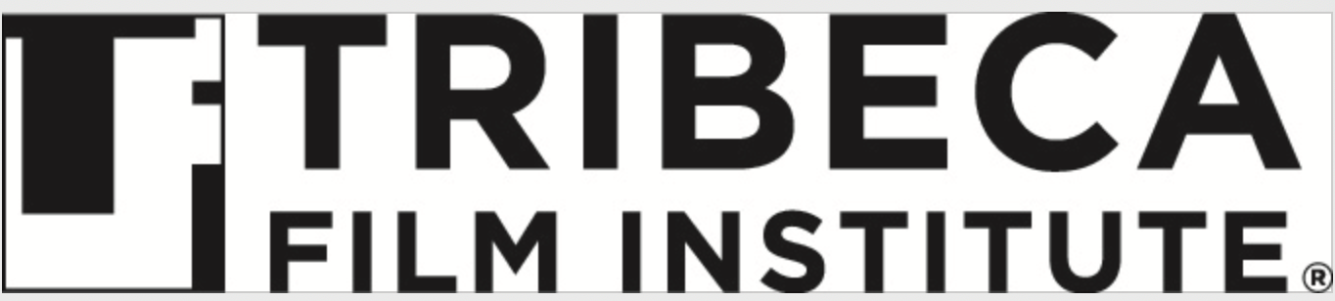

Produced with the assistance of
the Hot Docs first look Pitch Fund

Docs Port Incheon Award

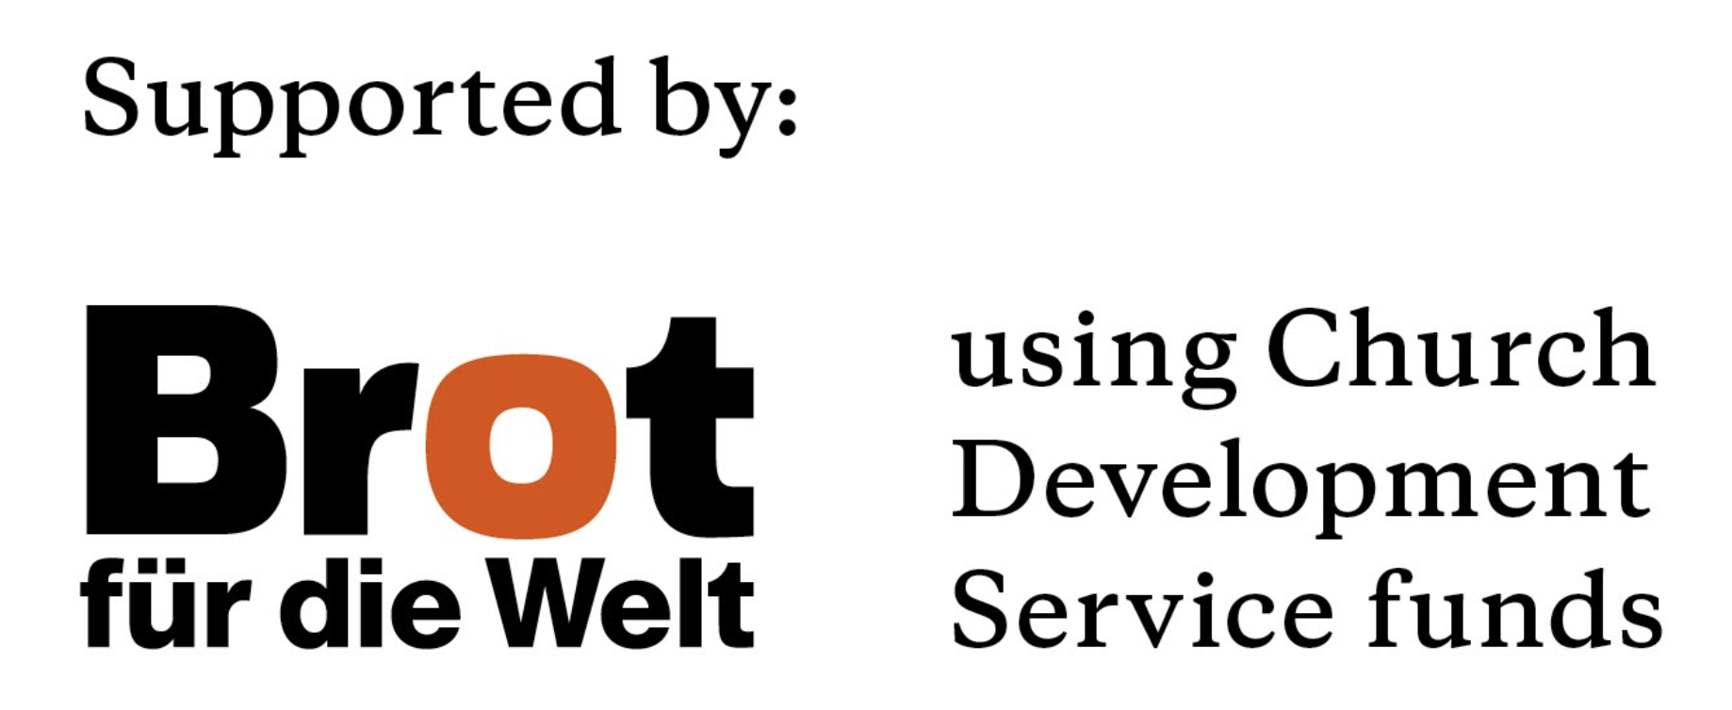

Produced with the assistance of
The Great Chicago Pitch
This project was completed with the support of
the Women Make Movies Production Assistance Program
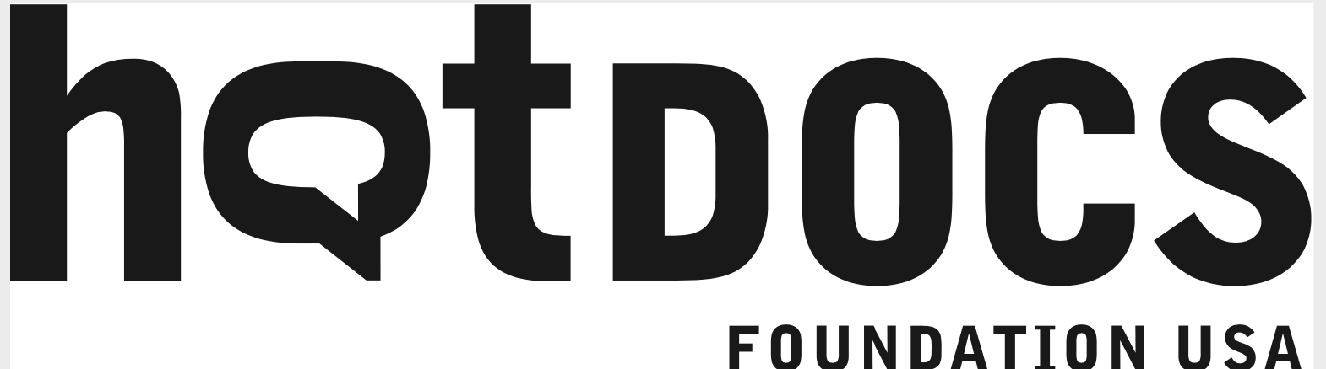
Hot Docs Foundation (USA), Inc.

This project was pitched at:
CMP Great Chicago Pitch
Dhaka Doc Lab
Docs By The Sea
Dok Leipzig Co-Pro-Market
Docs Port Incheon
Hot Docs Forum & Dealmaker

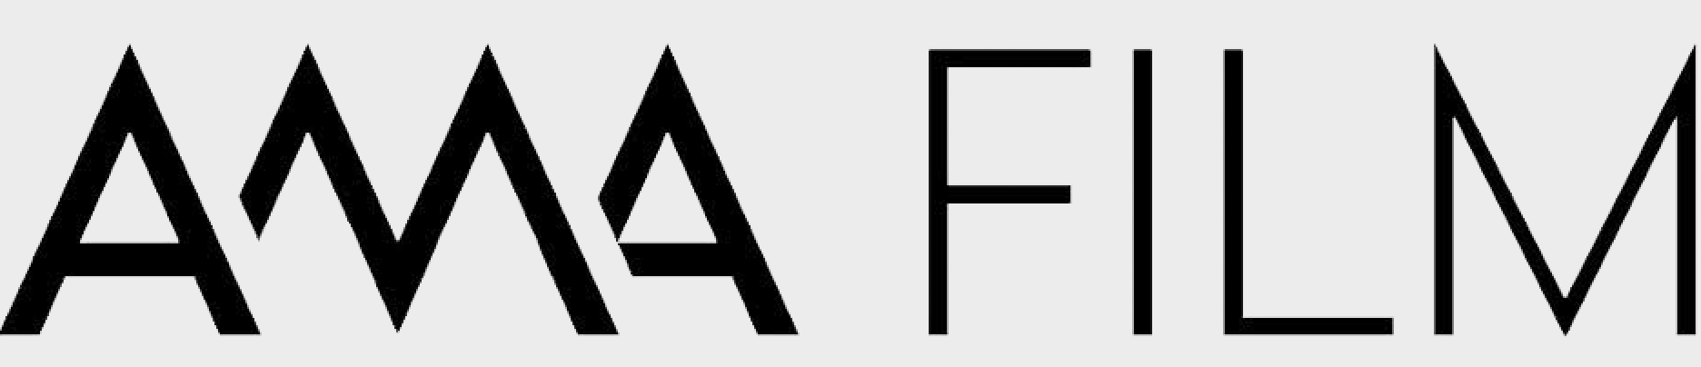
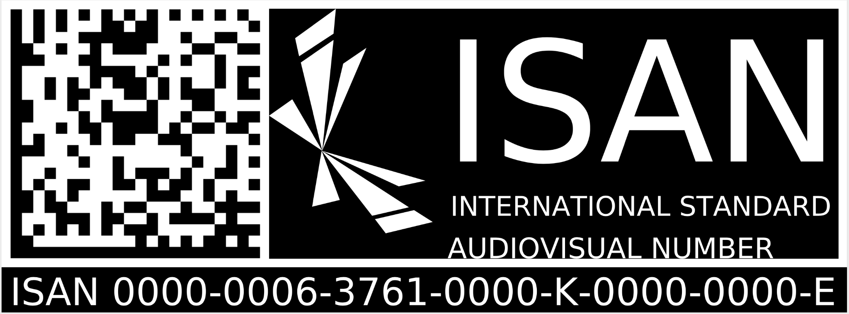

EyeSteelFilm Classics Inc, AMA FILM GmbH, and Snow Films
Copyright 2022

